Lets wish Horsbug98 on his birthday and jump right into the question.
In Chefland, 66 new mobile brands have appeared each providing a range of smartphones. For simplicity let the brands be represented by numbers 11 to 66. All phones are sold at the superstore.
There are total NN smartphones. Let PiPi & BiBi be the price and the brand of the ithith smartphone. The superstore knows all the price and brand details beforehand.
Each customer has a preference for brands. The preference is a subset of the brands available (i.e 11 to 66). Also, the customer will buy the KthKth costliest phone among all the phones of his preference.
You will be asked QQ queries. Each query consists of the preference of the customer and KK.
Find the price the customer has to pay for his preference. If no such phone is available, print −1−1
Note that for each query the total number of smartphones is always NN since, after each purchase, the phones are replaced instantly.
###Input:
- First Line contains NN and QQ
- Second-line contains NN integers P1,P2,…,PNP1,P2,…,PN (Price)
- Third line contains NN integers B1,B2,…,BNB1,B2,…,BN (Brand)
- Each of the next Q lines contains a query, the query is describes below
- First line of each quey contains bb and KK where bb is the size of the preference subset.
- Second line of each query contains bb integers, describing the preference subset.
###Output:
For each query, print the price to be paid.
###Constraints
- 1≤N,Q,Pi≤1051≤N,Q,Pi≤105
- 1≤Bi,b≤61≤Bi,b≤6
- 1≤K≤N1≤K≤N
###Sample Input:
4 2
4 5 6 7
1 2 3 4
3 3
1 2 3
3 4
4 5 6
###Sample Output:
4
-1
###Explaination
Query 1: The preference subset is {1, 2, 3}, The prices of phones available of these brands are {4, 5, 6}. The third costliest phone is 4.
Query 2: The preference subset is {4, 5, 6}, The prices of phones available of these brands are {7}.
Fouth costliest phone is required, which is not available. Hence, answer is −1−1.

前缀和处理每个种类的数有多少个，然后二分找每个坐标，减去没有用的数，就是他的真实排名。然后二分
WA：
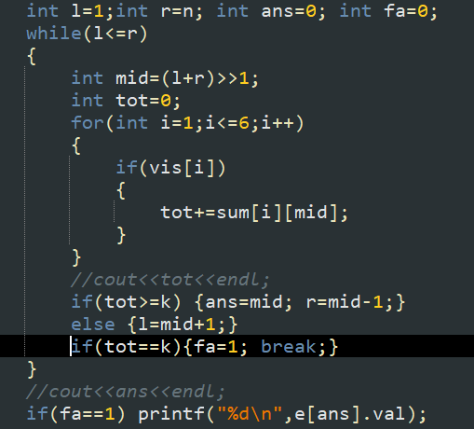
AC：
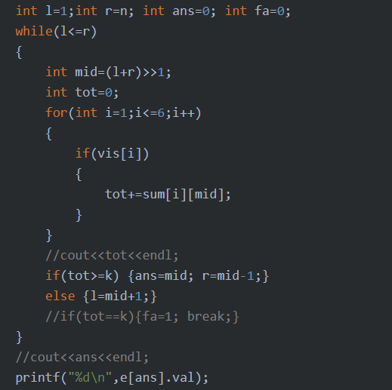
好像以前就遇到过这样把。。劝你还是不要瞎搞了

提升自己水平就好了，没必要在意这一场两场比赛
你这个人是不能夸的你忘记了吗

#include<iostream>
#include<cstdio>
#include<cstring>
#include<algorithm>
#include<map>
#include<vector>
#define ll long long
using namespace std;
int sum[10][100005];
int ct[10];
int vis[10];
struct node
{
int brand;
int val;
}e[100005];
int cmp(node a,node b)
{
return a.val>=b.val;
}
int main()
{ memset(sum,0,sizeof sum);
memset(vis,0,sizeof vis);
memset(ct,0,sizeof ct);

int n,q;
scanf("%d %d",&n,&q);
for(int i=1;i<=n;i++)
{
scanf("%d",&e[i].val);
}
for(int i=1;i<=n;i++)
{
scanf("%d",&e[i].brand);
ct[e[i].brand]++;
}
sort(e+1,e+1+n,cmp);
/*for(int i=1;i<=n;i++)
{
cout<<e[i].val<<" "<<e[i].brand<<endl;
}
*/
for(int i=1;i<=n;i++)
{
for(int j=1;j<=6;j++)
{
sum[j][i]=sum[j][i-1];
}
sum[e[i].brand][i]++;
/*cout<<"pos :"<<i<<endl;
for(int kk=1;kk<=6;kk++)
{
cout<<kk<<" "<<sum[kk][i]<<endl;
}

*/
}
for(int kk=1;kk<=q;kk++)
{
int b;
int k;
scanf("%d %d",&b,&k);
int summ=0;
for(int i=1;i<=6;i++) vis[i]=0;
for(int i=1;i<=b;i++)
{
int x;
scanf("%d",&x);
if(!vis[x])
{summ+=ct[x];vis[x]=1;}
}
if(k>summ) {printf("-1\n");continue;}
int l=1;int r=n; int ans=0; int fa=0;
while(l<=r)
{
int mid=(l+r)>>1;
int tot=0;
for(int i=1;i<=6;i++)
{
if(vis[i])
{
tot+=sum[i][mid];
}
}
//cout<<tot<<endl;
if(tot>=k) {ans=mid; r=mid-1;}
else {l=mid+1;}
//if(tot==k){fa=1; break;}
}
//cout<<ans<<endl;
printf("%d\n",e[ans].val);

}
return 0;
}

